Lunar Crater Radio Telescope (LCRT) on the Farside of the Moon
Saptarshi Bandyopadhyay¹, Ashish Goel¹, Gaurangi Gupta¹, Manan Arya², Nacer Chahat¹, Adrian Tang¹, Kalind Carpenter¹,
¹Jet Propulsion Laboratory, California Institute of Technology, ²Stanford University

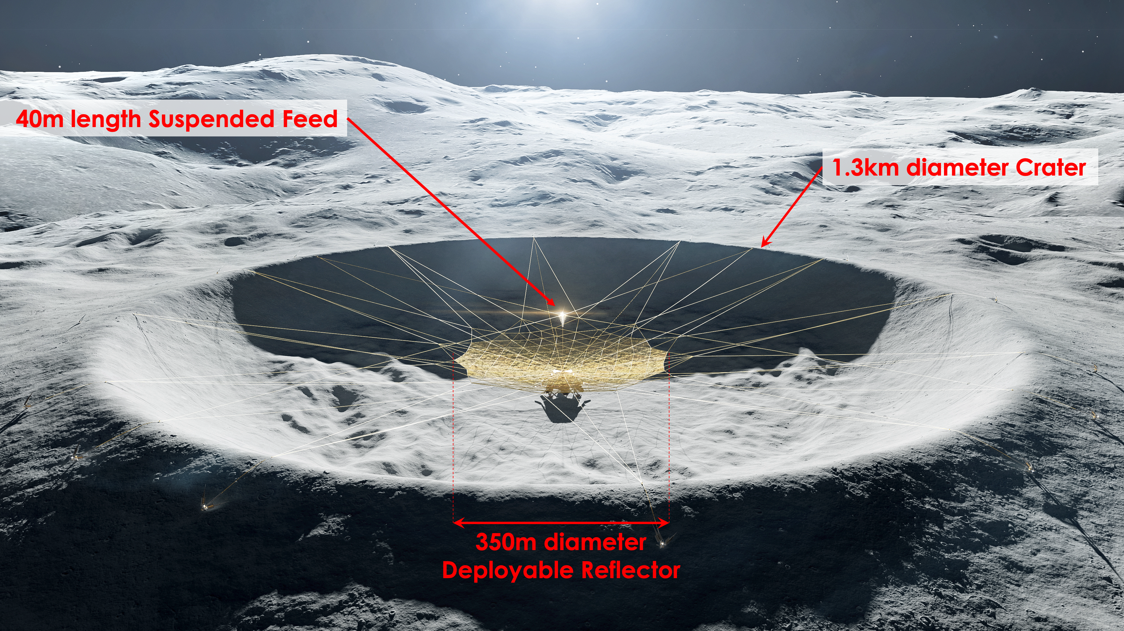
The Cosmic Dark Ages represent the period in the early evolution of the Universe, starting immediately after the decoupling of CMB photons from matter, and ending with the formation of the first stars and galaxies. The H_{I} signal from the neutral hydrogen atoms is the only mechanism for us to understand this crucial phase in the cosmological history of the Universe and answer fundamental questions about the validity of the standard cosmological model, dark matter physics, and inflation. Due to cosmological redshift, this signal is now only observable in the 4.7 – 47 MHz frequency band, which is blocked from reaching the surface of the Earth by the ionosphere and have not been explored by humans till date. We hence propose to carry out this measurement using a radio telescope on the far side of the Moon. In addition to being free from ionospheric effects, the far side of the Moon provides a radio-quiet environment for these measurements since it is shielded from terrestrial sources of radio frequency interference.
Figure 1: Concept art of LCRT on the farside of the Moon
We present the design of the Lunar Crater Radio Telescope (LCRT) mission concept that intends to carry out unprecedented measurements of this signal by deploying a 350m-diameter parabolic reflector mesh inside a lunar crater on the far side of the Moon and suspending a receiver at its focus. Our concept of operations employs a single lander which launches a sequence of projectile anchors onto the rim of the crater, establishing ‘lift wires’ that are then used to hoist the feed antenna followed by the deployment of the folded mesh reflector. We also describe the rationale for crater selection and technological solutions for achieving desired shape accuracy and thermal performance with our design.
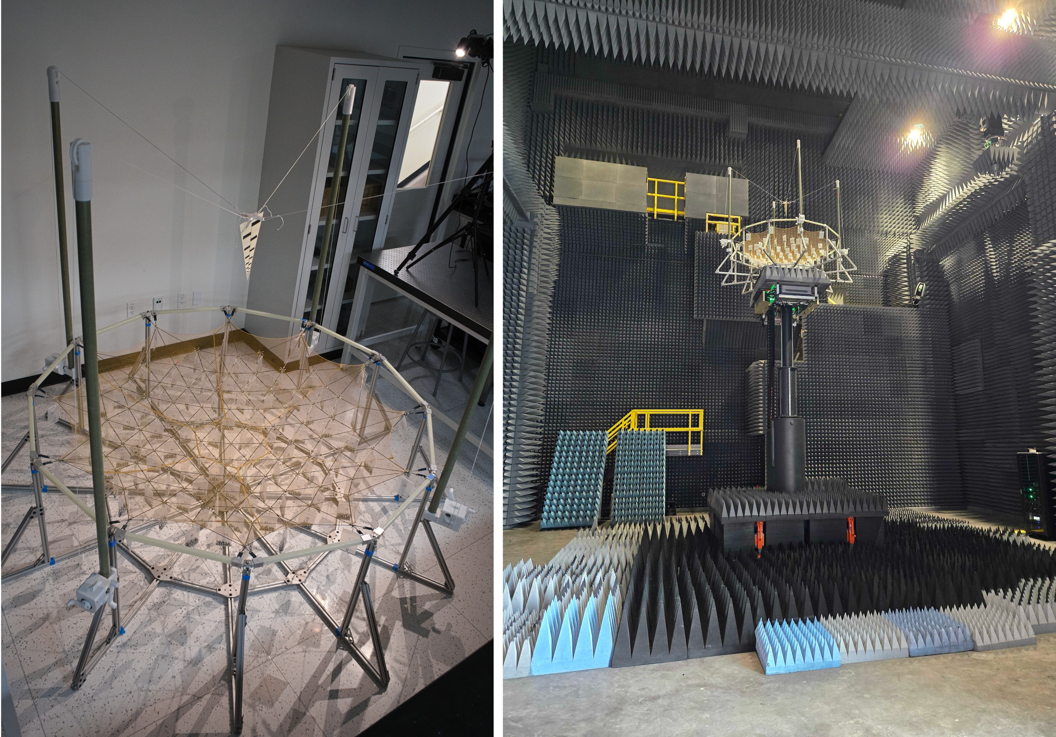
The LCRT mission concept is has been funded by the NASA Institute for Advanced Concepts (NIAC) Phase 1 and Phase 2 program and the NASA Astrophysics Research and Analysis (APRA) program. We have developed a 1/200-scale model of LCRT and performed detailed RF-characterization of this LCRT model at NASA Glenn Research Center. In the future, we will performing astronomical observations with this LCRT model at Owens Valley Radio Observatory (OVRO).
Figure 2: (a) 1/200-scale model of LCRT at Prof. Arya's lab in Stanford. (b) Detailed RF-characterization of 1/200-scale model of LCRT at NASA Glenn Research Center
The 2020 Astrophysics Decadal Survey recommended a probe-class mission (cost cap $1.5 Billion, excluding launch) for Dark Ages cosmology in the next decade (2030–2040). We believe LCRT is the leading candidate for this probe-class mission!

References:
[1] D. Pisanti et. al. “Modeling Science Return from the Lunar Crater Radio Telescope on the Far Side of the Moon,” Philosophical Transactions Royal Society A, March 2024. (DOI)
[2] S. Bandyopadhyay et. al. “Lunar crater radio telescope (LCRT) on the far side of the Moon,” NASA Innovative Advanced Concepts (NIAC) Phase 2 Report, 2023. (PDF)
[3] S. Bandyopadhyay et. al. “Lunar Crater Radio Telescope (LCRT) on the Far Side of the Moon,” NASA Innovative Advanced Concepts (NIAC) Phase 1 Report, 2021. (PDF)

